Little Angels
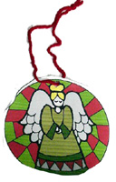
This project is fun for the whole family.
This project is rated VERY EASY to do.
What You Need
- Angel printout (see below)
- Scissors
- Glue
- Hole punch
- Ribbon or string
- Cereal box
- Crayons, optional
How To Make It
- Print out a picture of an angel in black and white or color.
- If you printed a black and white page, let the child color the angel with crayons.
- Cut it out.
- Glue to a square piece of cereal box cardboard.
- Cut the cereal box piece around the angel.
- Punch a hole in to it.
- Tie a piece of string or ribbon through the hole.
- Now hang it on the Christmas tree.

Ribbon Angel Ornament
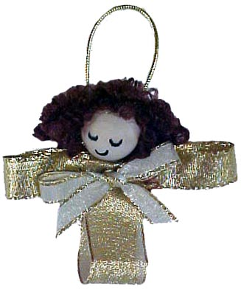
Imagine a tree filled with these angels and big gold shiny bows!
Parental supervision is recommended.
This project is rated AVERAGE to do.
What You Need
- 1" Wide gold ribbon
- 5/8" Wide Medium gold ribbon
- 3/8" Wide Narrow gold ribbon
- 9" Gold cord
- 16 mm Wooden bead
- Curly doll hair
- Low temp glue gun
- Black permanent marker
- Ruler
- Scissors
How To Make It
- Cut wide ribbon in a length of about 4 inches.
- Cut medium ribbon twice as long (about 8 inches).
- Using the low temp glue gun, glue wide ribbonís CUT edges together.
- Glue medium wide ribbon's CUT edges together.
- Tie one end of the cord tightly (to squeeze into bow shape) around the middle of the medium wide ribbon (both layers).
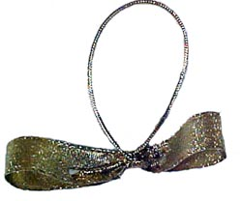
- Loop over other end and hot glue to where you tied it, to make loop in back. (See photo)
- Glue the medium ribbon (wings) to top back of wide ribbon (skirt).
- Draw shut eyes and mouth on bead with permanent marker.
- Glue hair on top.
- Glue bead (head) to top of ensemble (will have little fold place on top of wings, where it was squeezed by cord).
- Tie bow with narrow ribbon and glue on the front, below the angel's head. (See photo)
- Hang on the tree or tie to a package and enjoy!

Fabric Angels
These are great for tree decorations, gift decorations or just an added something for a wall grouping. They can be made in any color or fabric design and for any season.

Parental supervision is recommended.
This project is rated AVERAGE to do.
What You Need
- Fabric of any color or design
- Two different size circles to trace around
- Thread
- Lace
- Ribbon
- Foil garland or pearl strings
- Hot glue
- Sewing machine or needle and thread
- Cotton balls or stuffing
How To Make It
- Using two different size circles (I use a plate and a cereal bowl), cut one circle of each size from fabric for each angel. The larger circle is the body and the smaller circle the wings.
- Sew lace around each circle.
- Put a cotton ball or small amount of stuffing in the middle of the large circle. Using a piece of thread, tie the material to make a head.
- Take the smaller circle, and tie tight a piece of thread in the middle to form wings. (This will make two fan shapes for the wings.) Tie the wings around neck of the body.
- Take a piece of ribbon, and tie it around the neck to hide the thread. Make it into a bow.
- Glue a halo, using pearls or garland, onto the head.
- Sew a small loop of thread to the back of the angel to hang her by.
- Enjoy. :-)

Angel Ornament
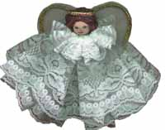
This project is simple and quick fun.
Parental supervision is recommended.
This project is rated AVERAGE to do.
What You Need
- 20" of 4" wide gathered lace
- 10" of 1" wide gathered lace
- 7/8" round wood bead or turning
- Craft hair
- 1 square of white felt
- Paint - brown or blue for eyes, red for lips
- Craft wire
- Braided cord
- 10" Fishing line or heavy duty clear thread
- Hot glue gun
How To Make It
- Gather 20" piece of 4" wide lace on wire and twist wire together for dress.
- Hot glue wood bead on top of gathered lace.
- Gather 10" piece of 1" wide lace on wire for collar, twist closed around base of head.
- Make wings out of felt in shape of a butterfly. Trim with braided cord around edge.
- Glue craft hair on the top of the bead.
- Cut a piece of braided cord to fit top of head (as halo) and glue ends together. Glue on top of hair.
- Knot piece of fishing line together. Lay on top of wings with the loop above the wings (to use an hanger).
- Generously glue wings to the back of angel.
- Paint eyes and mouth on wood bead for face.

Angel and Singer Ornaments

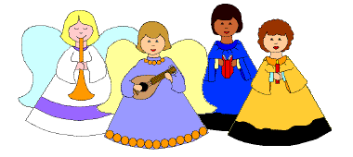
This project lets you make 2 styles of paper cone ornaments, one set with the arms drawn right on the body, and the other with separate arms attached to the ornament, for a more 3-D effect. The ones with the arms drawn right on the body are easier to make, and well suited for younger children.
There are 3 different angels and 3 different choir singers in each style.
Young children (like my 6 year old) might want help with the cutting around the head/neck area. Also a good thick glue (we use Aleene's Tacky Glue) makes things go together much more easily.
This project is rated EASY to do.
What You Need
- Crayons, markers, or colored pencils
- Computer paper
- Scissors
- Glue
- Yarn or ribbon, if you want to hang the ornament
